WAYANAD APP

# **AIM**

TO CREATE A DONTION PAGE FOR WAYAND FLOOD

# **PROCEDURE**

* Create a wireframe according to the mobile application
* Select the basic theme for page to be created
* Use different shapes to create layout as menu icons
* Use assessts options to get different components to implement

Get the needed images to make it look unique

* Make a donation themed app
* Keep various options for app

## IMAGE

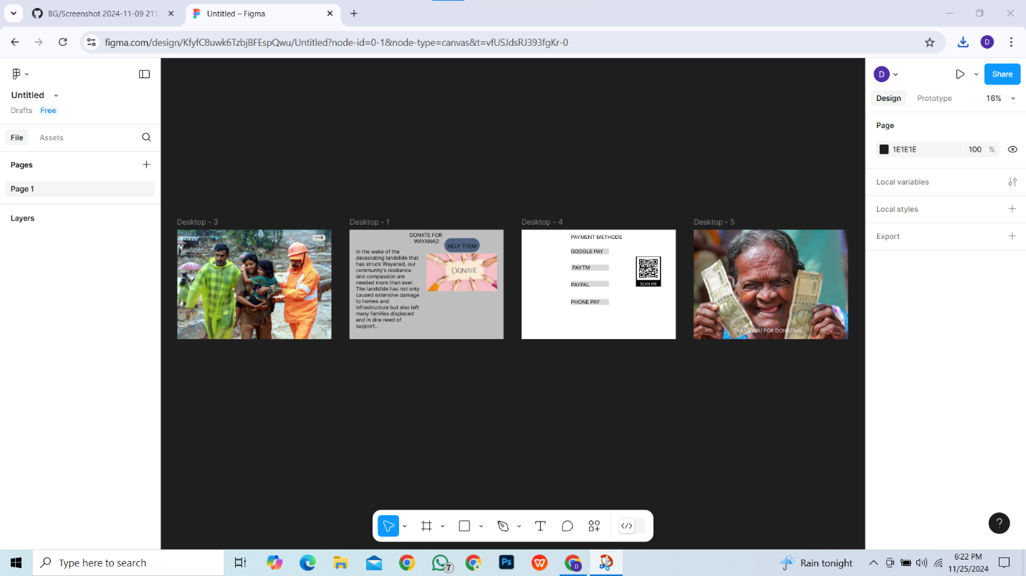

## RESULT

WAYANAD DONATION APP IS DESIGNED